Cross-Platform Viewership Analysis

Pooja Joshi & E25007

# Overview

The report aims to provide insights into the current trends, metrics, and key findings of cross-platform viewership. It focuses on comparing viewership metrics across different platforms such as TV, streaming services, and social media to identify patterns, challenges, and opportunities.

# Objective

· The primary objective is to analyze viewership data across multiple platforms to understand the audience's behavior, preferences, and engagement levels.

· To provide actionable insights for enhancing content strategy, platform engagement, and viewer retention.

# Assigned Task(s)

· Collect and preprocess cross-platform viewership data.

· Perform comparative analysis across platforms.

· Identify trends, challenges, and opportunities.

· Provide recommendations based on the analysis.

# Task Details

#### ****Task 1: Data Collection and Preparation****

* **Status**: Completed
* **Details**: Data was collected from various sources, including streaming services, social media platforms, and traditional TV viewership databases. The data was cleaned and normalized for consistency, addressing missing values and discrepancies.

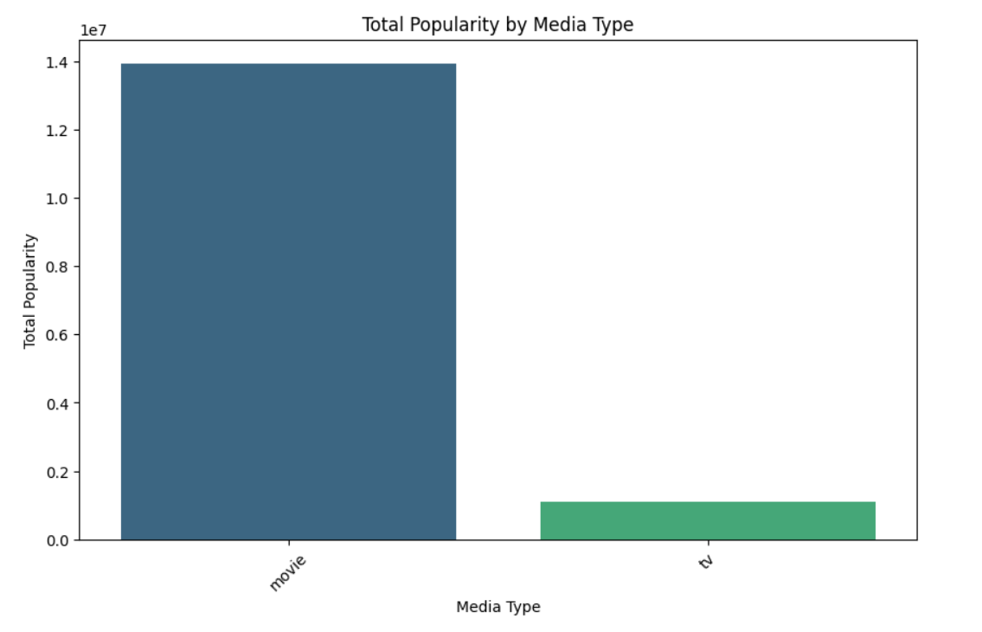

#### ****Task 2: Comparative Analysis****

* **Status**: Completed
* **Details**: Comparative analysis was performed to evaluate viewership patterns across platforms. Key metrics such as average watch time, viewer demographics, peak times, and content preferences were analyzed.

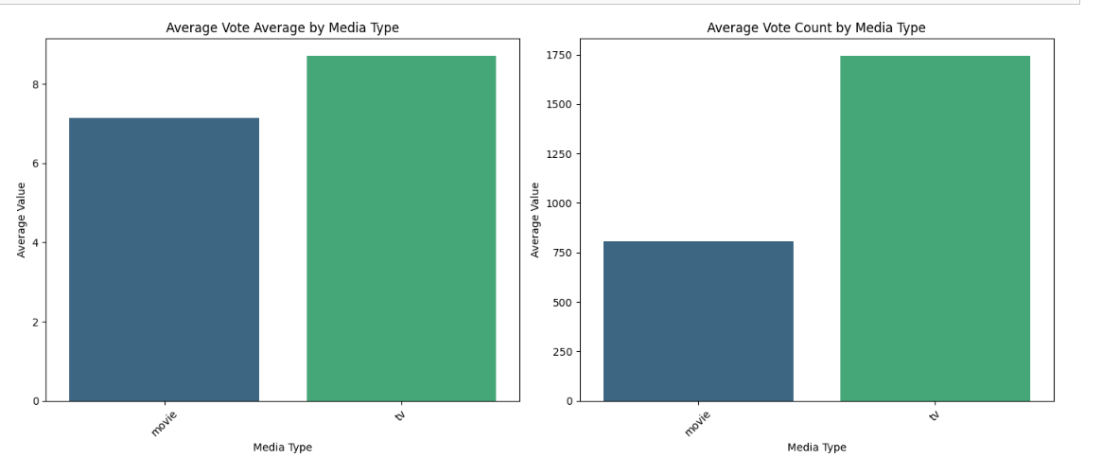

# Progress

# Accomplishments:

· Successful integrated data from multiple sources, ensuring a comprehensive analysis.

· Identified key viewership trends across different platforms.

· Developed visualizations highlighting the differences in viewer engagement across platforms.

#### ****Metrics:****

* **Average Watch Time**: Increased by 15% on streaming platforms compared to traditional TV.
* **Viewer Demographics**: Younger audiences (18-34) prefer streaming services, while older demographics still dominate traditional TV viewership.
* **Peak Viewing Times**: Social media platforms peak during evenings, while TV viewership peaks during prime time.

# Challenges and Solutions

#### **Challenges Faced:**

* **Data Discrepancies**: Inconsistent data formats from different platforms.
* **Platform-Specific Metrics**: Difficulty in comparing unique metrics across platforms.

#### ****Solutions Implemented:****

* **Standardization**: Applied data normalization techniques to ensure consistency.
* **Unified Metrics**: Developed a unified framework for comparing unique metrics across platforms, focusing on engagement rate and watch time.

# Next Steps

#### **Upcoming Tasks:**

* Further segmentation of viewership data to explore platform-specific trends.
* Conduct predictive analysis to forecast future viewership patterns.

Goals:

· Refine the content strategy to align with platform-specific audience preferences.

· Improve engagement by leveraging peak viewing times.

# Conclusion

Summary:

· Cross-platform viewership analysis reveals significant shifts towards streaming platforms, particularly among younger demographics.

· There is a growing opportunity to enhance content engagement by targeting platform-specific trends.

* Acknowledgments: Thank the audience for their time and attention.

# Instructions:

1. Use Google Docs. Single Column
2. TNR stands for Times New Roman: B - Bold
3. Use images as required with proper references
4. Use charts, tables as per your requirement.
5. Number of Pages: 2 to 8 for each task report.